Wireframes, sitemap and visual design

OnFest

Version 1 – Added all of the separate files into one.

Course: ProP

Group: 31

Dimitar Parpulov - 3207358

Diqin Yang - 3324087

Dongdong Ke - 3338207

Phat Tran - 3335968

1. Home

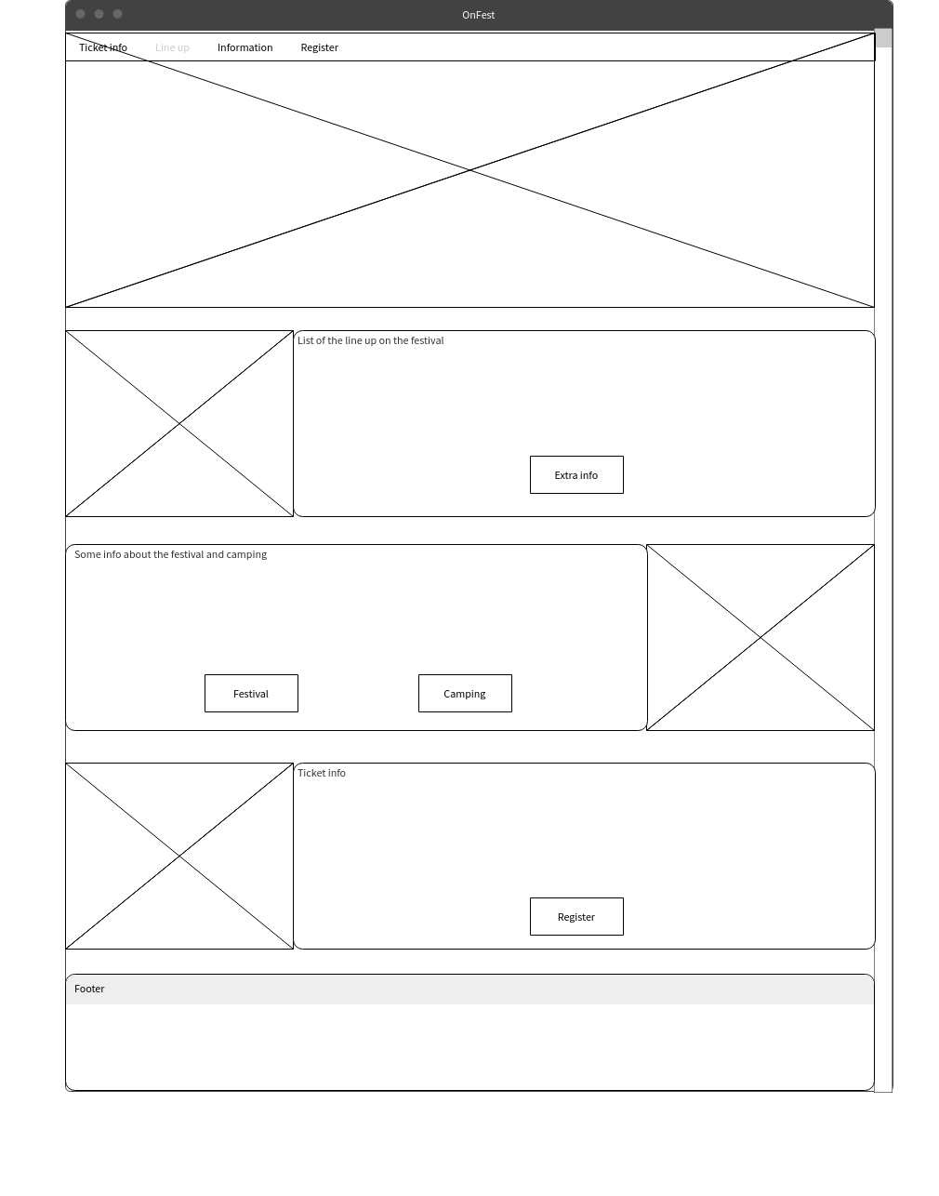

1. Register

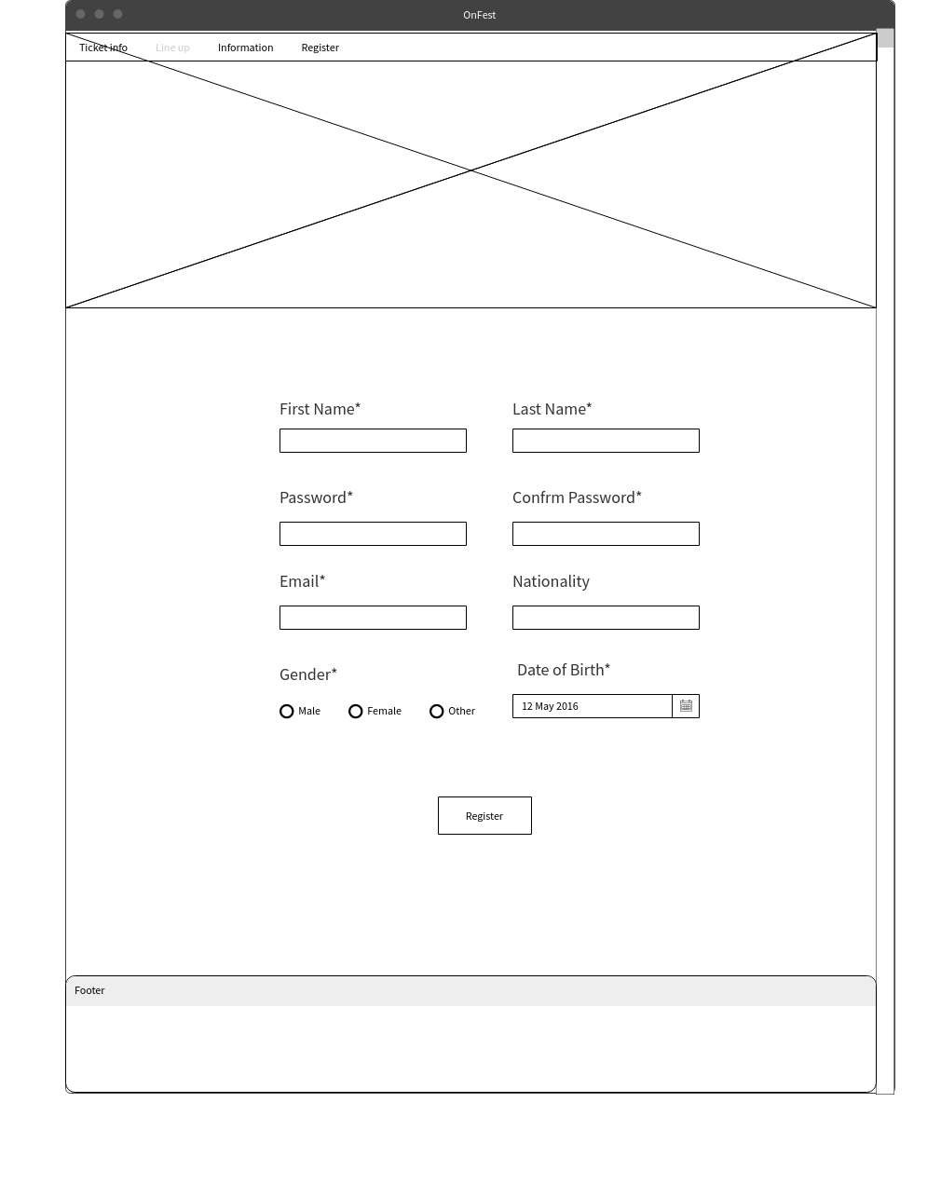

1. Log in

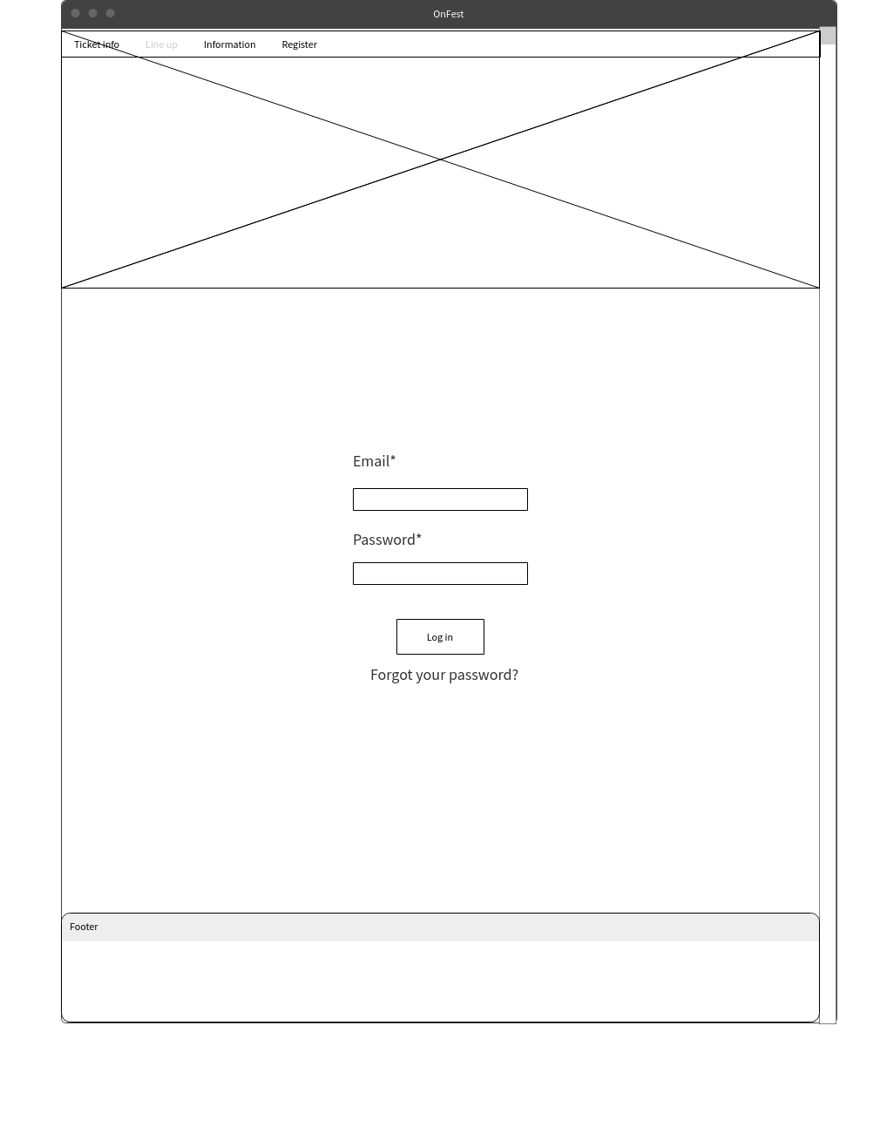

1. Information

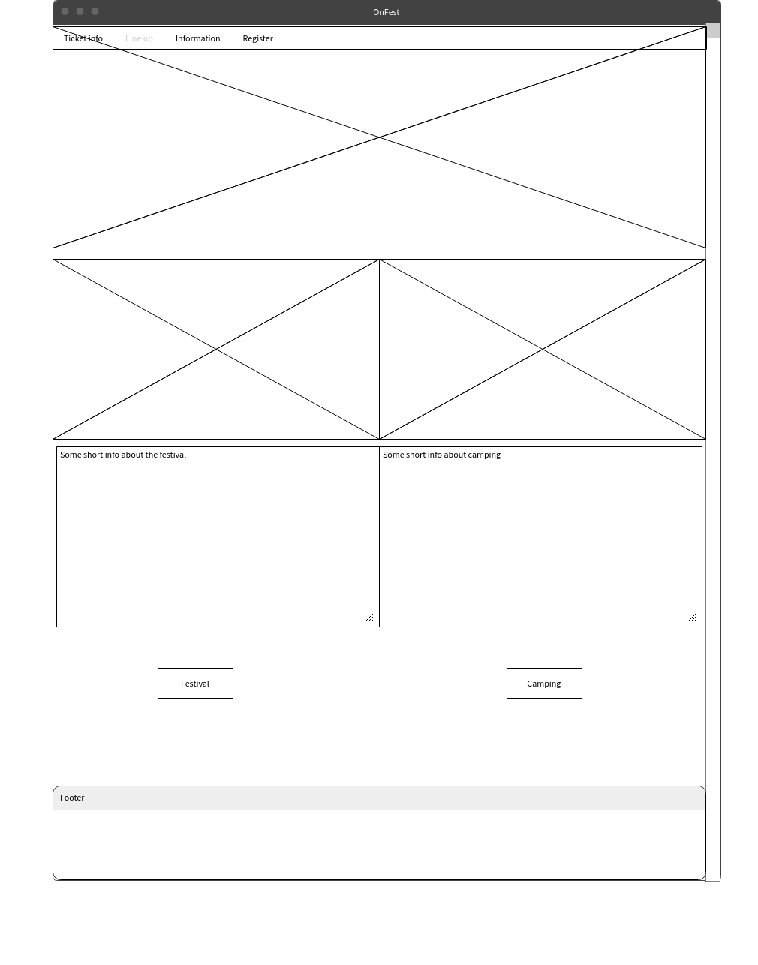

1. Line up

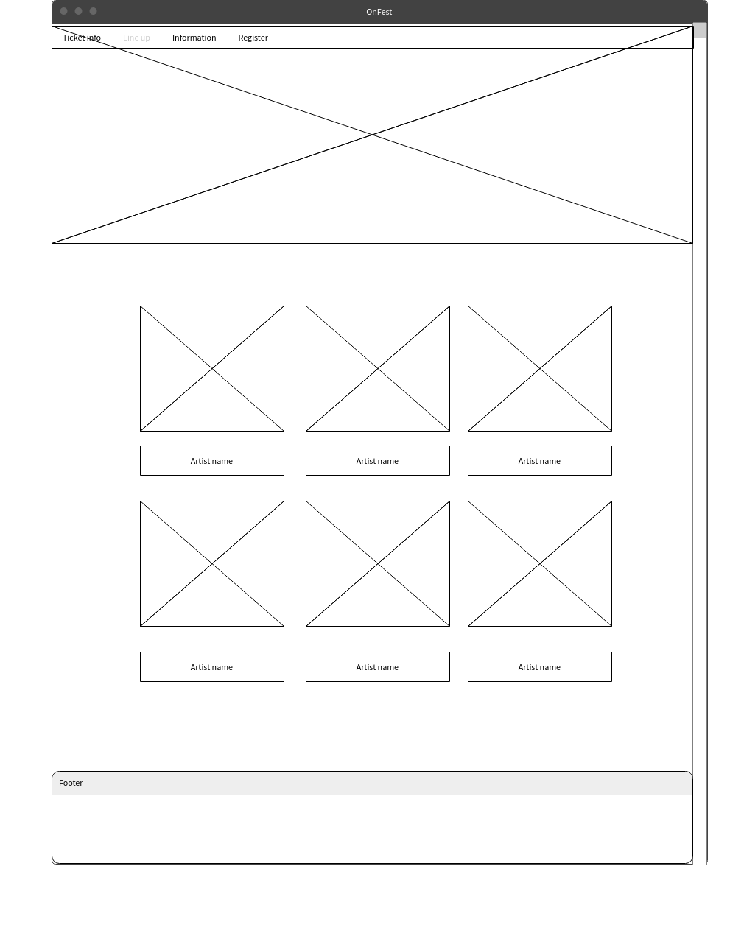

1. Account info

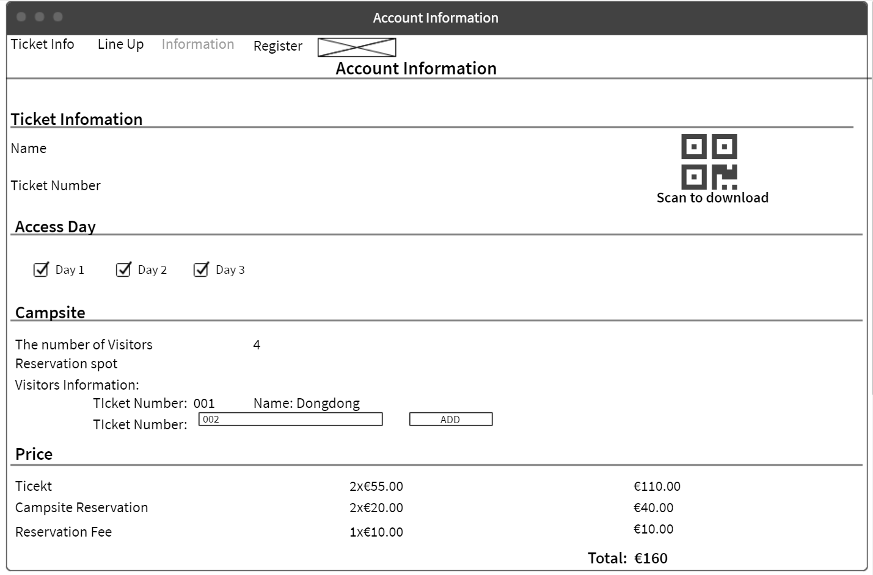

1. Deposit

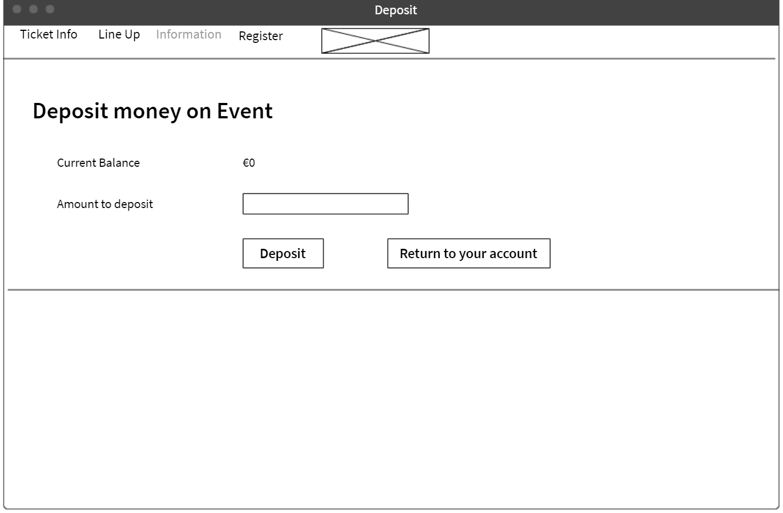

1. Visual design
2. Sitemap

